EDA Chief Executive in Slovenia for talks on EU defence cooperation

Ljubljana - 18 September, 2019

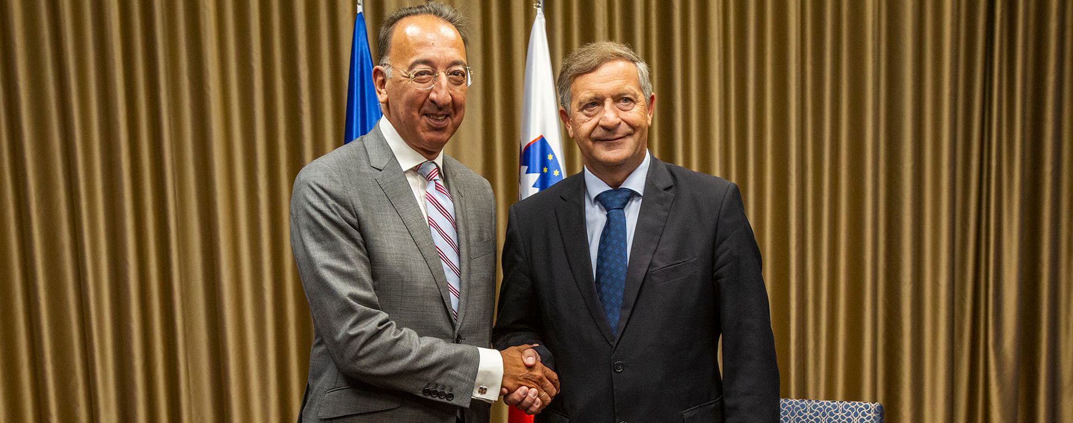

**EDA Chief Executive Jorge Domecq travelled to Ljubljana today for talks with Slovenian Minister of Defence Karl Erjavec, State Secretary Miloš Bizjak, as well as other high-level military and industry representatives.**

The main topics discussed during the bilateral meetings included the state of play and way forward of the various EU defence initiatives (CARD, PESCO, European Defence Fund) and the implementation of the 2018 EU Capability Development Priorities (CDP). Particular emphasis was put on the need to ensure coherence among the EU defence initiatives and a steady focus on the agreed CDP priorities.

The meetings also focused on Slovenia’s participation in EDA projects and programmes. Minister Erjavec and Mr Domecq for example exchanged views on the next steps regarding the RES-HUB (Defence RESilience Hub Network in Europe) project, an innovative Slovenian project proposal on building a renewable energy harvesting and hydrogen (H2) energy storage capability within the EU. The project was elaborated in the context of the Consultation Forum for Sustainable Energy in the Defence and Security Sector (CF SEDSS) with the support of EDA.

*“Slovenia offers our continuous support to the Agency’s role as the forum for prioritisation, project support and interface towards wider EU policies. Of special importance, we see the Agency’s interactions with the European Commission in regard to its role in establishing the European Defence Industrial Development Programme (EDIDP) and European Defence Fund. We also believe that EDA as a part of the PESCO secretariat has been crucial in the development of projects, establishing dialogue between Member States and providing coherence between different defence and security initiatives on the EU level.*

*A project which we will try to facilitate through the EDA format is the project RES-HUB. Further development of this project is essential for us in view of decreasing the carbon footprint in the defence sector. We see this project as a possibility to highlight our efforts during our Presidency in the second half of 2021”*, Minister Erjavec said during the meeting.

*“It is very important for the European Defence Agency to have a clear idea of what the Slovenian authorities expect from the Agency in this crucial moment of EU defence cooperation. After the successful launch of the different EU defence initiatives, the emphasis is now on the implementation of PESCO and CARD as well as the European Defence Fund. At the same time I welcome Slovenia’s RES-HUB initiative as the project has the potential to contribute to more energy resilient European armed forces,*said Mr Domecq.

During his visit, the EDA Chief Executive also welcomed the possibility to exchange with the Slovenian defence industry on matters of EU defence cooperation.